**Team 13: Java Swing app, Android and iOS app for IHO department**

Sponsor: Dr. Timothy Lindquist

Jaiswal, Arpit; Bhatt, Mihir; Nayak, Gowtham; Singhal, Sweta; Senathamil, Sindhu

**https://github.com/swetasinghal28/IHO/**

**Coding Report: GitHub Home + One directory showing Code Directory (iOS, Anroid and Swing)**

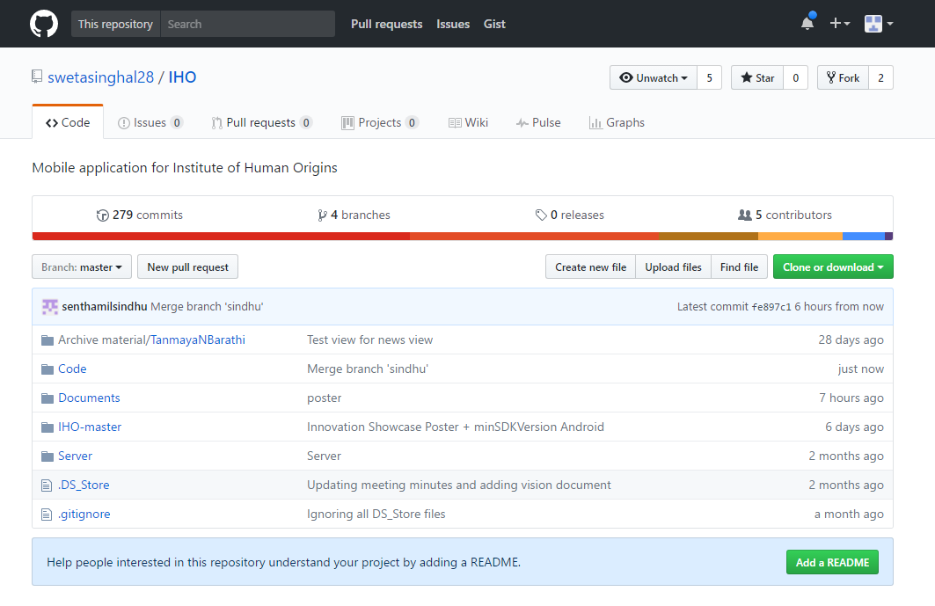

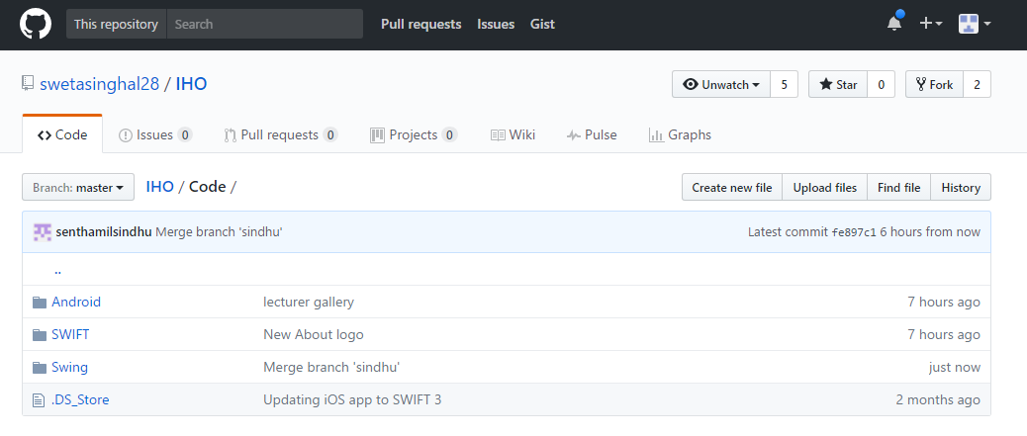

**Coding Report: GitHub Contributors**

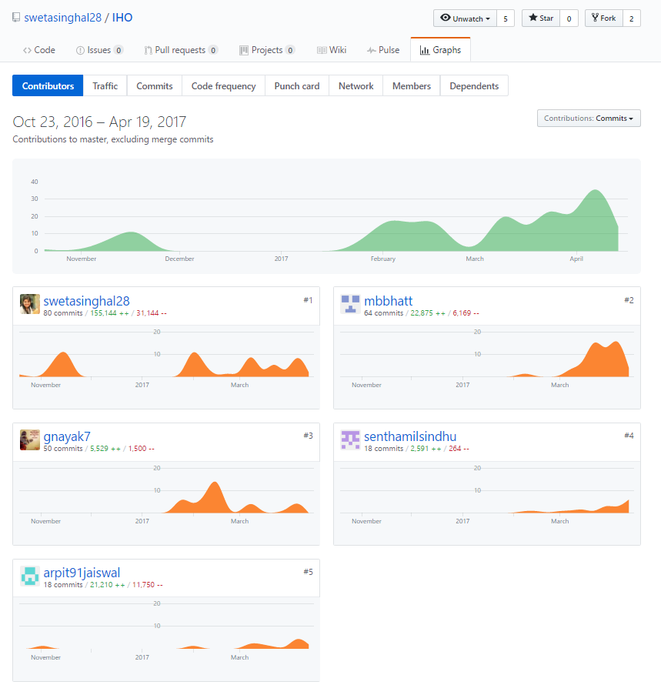

**Coding Report: Punch Card**

